LAB REPORT-6

Snigdha stp

2023102036

G-6

Experiment-1

Objective: Preparing 7-Segment Decoder

Electronic components:

1) One 4-Bit Ripple Counter

2) One BCD to 7-Segment Latch Decoder Diver

3) One 7-Segment Display

4) 1 Resistor

5) One LED

Procedure:

1)Make all connections in the timer as shown in the figure.

2)Connect output 3 of the timer to the 4-bit ripple counter and make all the connections as shown in the figure.

3)Connect the final outputs of the Diver to the 7-segment display as shown in the figure.

4)Connect the COM of the 7-segment display to GND using a resistor as shown in the figure.

Block Diagram:

Observation: The 7-segment display displays numbers 0 to 9 by glowing respective LEDs.

Truth Table:



Reference Circuit:

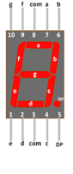

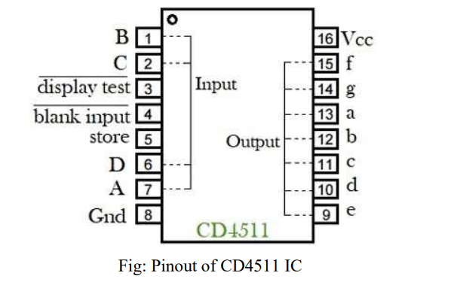

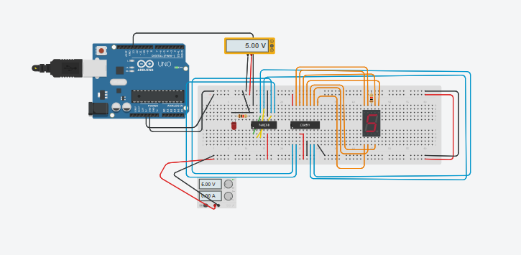

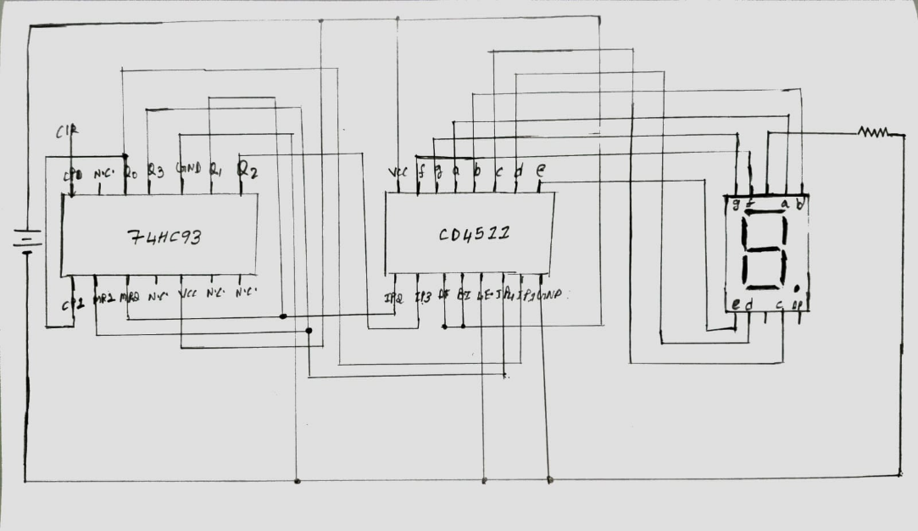

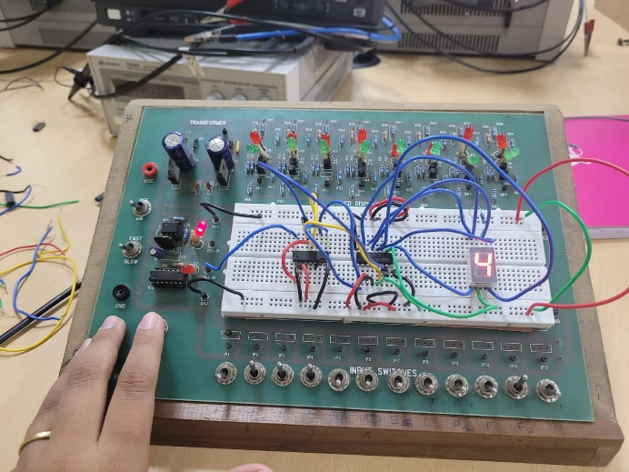

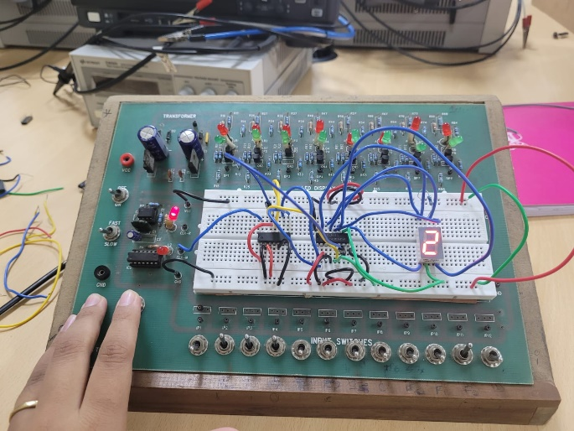

Tinkercad link:

<https://www.tinkercad.com/things/9i7AsuXVF5g-terrific-jaban-uusam/editel?sharecode=E-NXl08KvxLmcr9v-K5JETiEvUH73fbbLBXYHKsugzg>

Experiment-2A

Objective: Using the circuit made above write the code to count from 0 to 255 and glow the 8 LEDs in order.

Electronic components:

1) One Arduino Uno R3

2) Eight LEDs

3) Eight Resistors

4) One Shift Register (IC – 74HC595)

Procedure:

1) Give 3 inputs to the Shift Register from the Arduino and other necessary inputs to drive Shift Register.

2) Connect the Output Pins of the Shift Register to the Anode of the LEDs and the Cathode of the LEDs to terminal 2 of the resistors such that terminal 1 of those resistors is grounded.

3) Execute the following code,

// ST_CP pin 5

const int latchPin = 3;

// SH_CP pin 3

const int clockPin = 4;

// DS pin 4

const int dataPin = 2;

void setup ()

{

// Setup pins as Outputs

pinMode(latchPin, OUTPUT);

pinMode(clockPin, OUTPUT);

pinMode(dataPin, OUTPUT);

}

void loop() {

// Count from 0 to 255 and display in binary

for (int numberToDisplay = 0; numberToDisplay < 256;

numberToDisplay++) {

// ST_CP LOW to keep LEDs from changing while reading serial data

digitalWrite(latchPin, LOW);

// Shift out the bits

shiftOut(dataPin, clockPin, MSBFIRST, numberToDisplay);

// ST_CP HIGH change LEDs

digitalWrite(latchPin, HIGH);

delay(500);

}

}

Reference circuit:



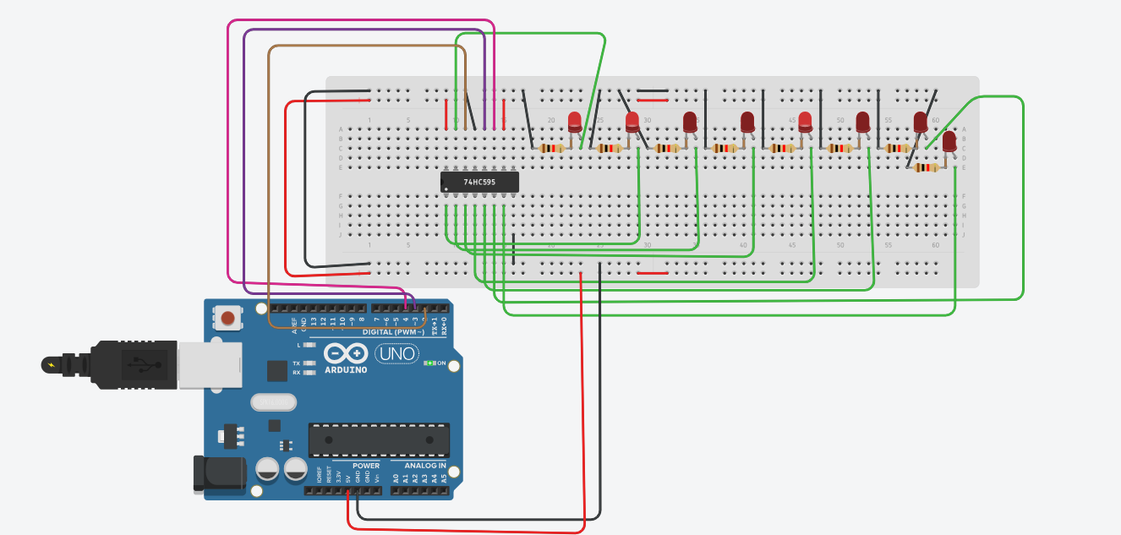

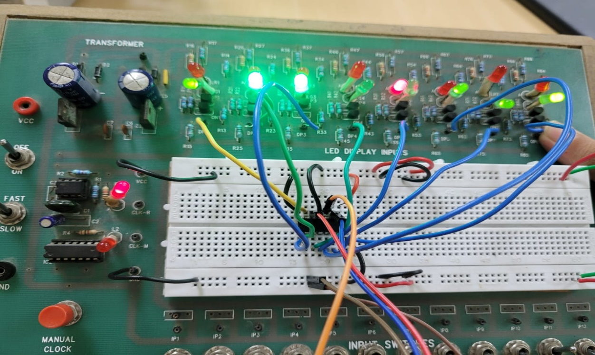

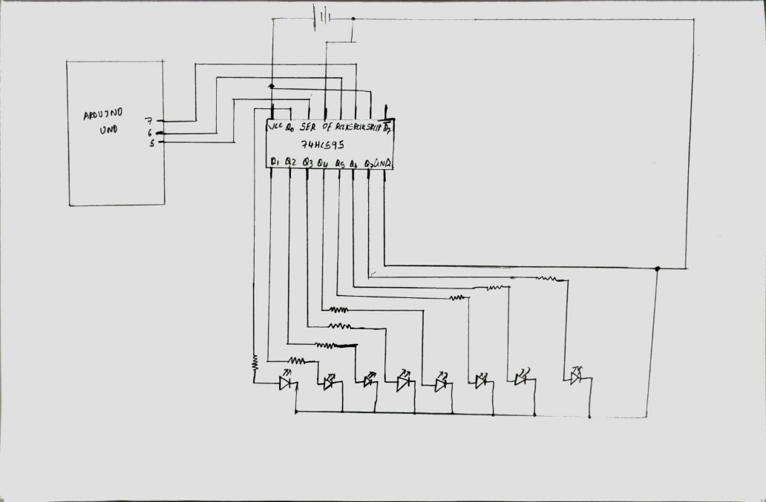

Observation: The bulbs will glow in such a way that it represents the numbers 0 to 255 in the binary form.

Note: If a bulb glows, it represents the number 1; if it doesn’t glow, assume that it represents the number 0.

Tinkercad link:

<https://www.tinkercad.com/things/8rIJxSpKQQo-brilliant-amberis/editel?sharecode=rWNtBE3Tv9HKNkT0kx_c_QDplDb1mGpuOmZvbFwgejg>

Experiment-2B

Objective: Using the circuit made above write the code to take input from the user (range 0-7) and glow the corresponding LED.

Electronic components:

1) One Arduino Uno R3

2) Eight LEDs

3) Eight Resistors

4) One Shift Register (IC – 74HC595)

Procedure:

1) Give 3 inputs to the Shift Register from the Arduino and other necessary inputs to drive Shift Register.

2) Connect the Output Pins of the Shift Register to the Anode of the LEDs and the Cathode of the LEDs to terminal 2 of the resistors such that terminal 1 of those resistors is grounded.

3) Execute the following code,

int latchPin = 3;

int clockPin = 4;

int dataPin = 2;

int leds = 0;

int k;

void setup()

{

pinMode(latchPin, OUTPUT);

pinMode(dataPin, OUTPUT);

pinMode(clockPin, OUTPUT);

Serial.begin(9600);

}

void loop()

{

leds = 0;

updateShiftRegister();

Serial.print("\nEnter Number-");

while(Serial.available() == 0){}

leds = Serial.read();

leds = leds - '0';

Serial.println(leds);

k = 1;

for(int i = 0; i <= leds; i++)

{

if(i == 0)

k = 1;

else

k = k * 2;

if(i == leds)

{

updateShiftRegister();

}

}

}

void updateShiftRegister()

{

digitalWrite(latchPin, HIGH);

shiftOut(dataPin, clockPin, MSBFIRST, k);

digitalWrite(latchPin, LOW);

}

Reference circuit:

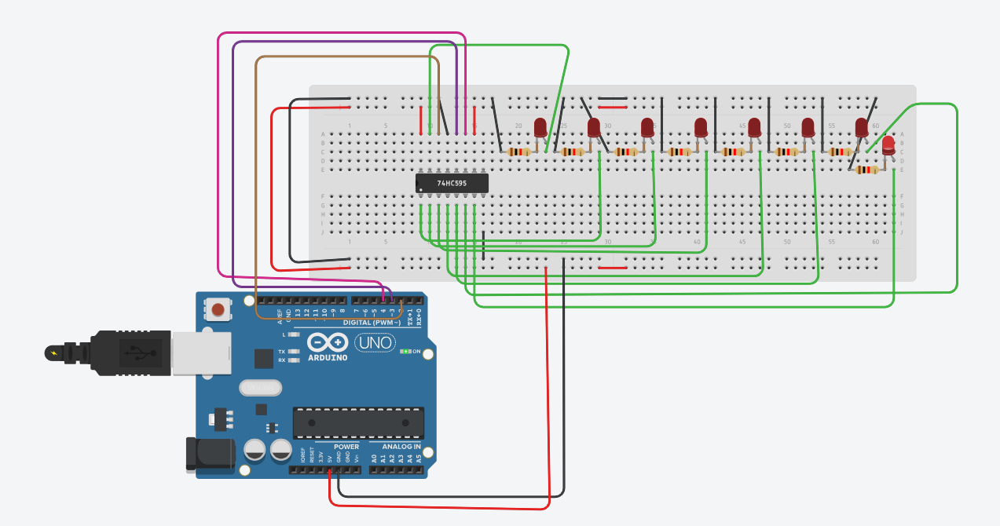

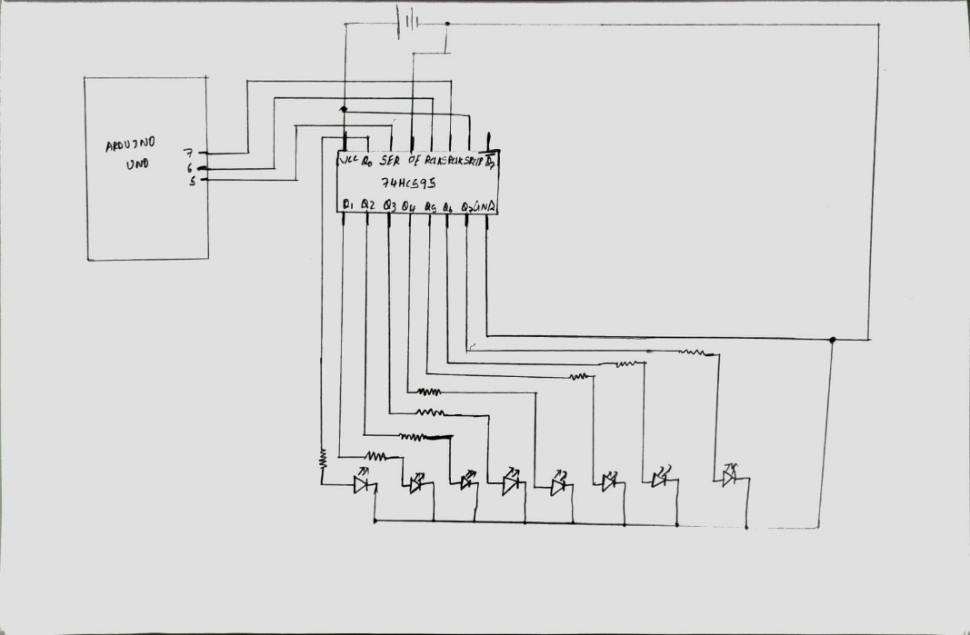

Tinkercad link:

<https://www.tinkercad.com/things/knv57w7RqBj-dazzling-kasi-allis/editel?sharecode=yy9lpC_Zez0oqeWTfMYlD1_Fj3FkYtY-Rav4np6M8dk>